Modern GfxRip Manual
Contents
1 GfxRip Tutorial 1
1.1 The Basis 1
1.1.1 Introduction 1

GfxRip Tutorial
Tutorial was written by Dj. Thunder. It can be located at http://b3dgs.com/gfxrip/. It has been included to make it easier for new users of GfxRip to learn how to use the program without having to search the Internet for example. The tutorial has been updated to reflect the new UI provided by Modern GfxRip.

The Basis

Introduction
Welcome to 'GfxRip Tutorial', a tutorial for ... ok ...:p.
This part is for people who never used GfxRip, and so, would like to know the basis.
You will discover the main part of this tool, what they mean, how to work with ... Let's go ! ( If you already know how it works, you can skip this part and go to the next one. )

The Beginning
As you should know it, GfxRip allows you to rip 'everything' from a game ( if you expect to rip musics ... go away ;) )
What will you see after launched the tool ?

Here the 1st screen:
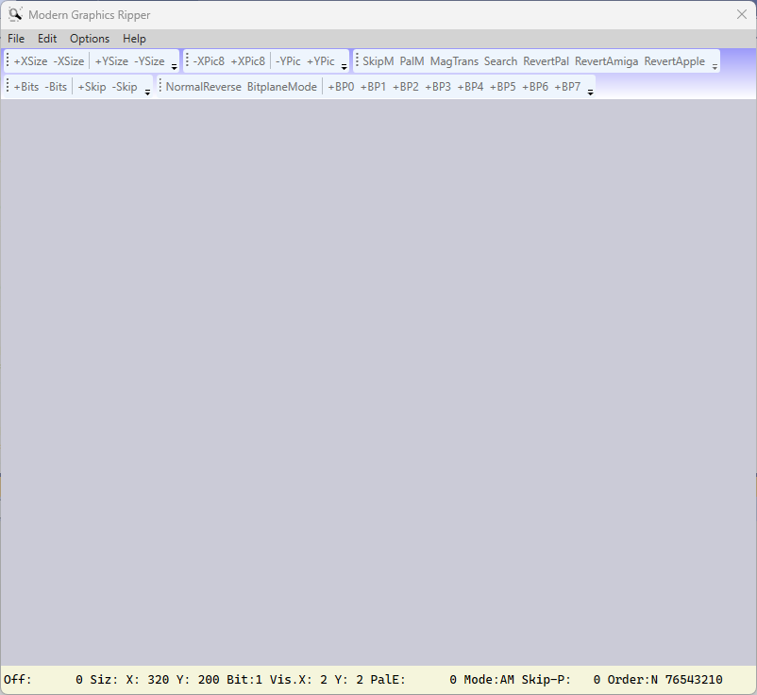
Select File -> Load Binary… or press the O key. It will bring up an Open File Dialog. Select the binary file that will be ripped.
At the bottom of the window will appear a status bar.
- This is the offset value.
0 means you are at the beginning of the memory you are reading.
You can move in this memory using "Arrowkeys" ( UP, DOWN, RIGHT, LEFT ) or (-XPic8, +XPic, -YPic, and +YPic) buttons in the toolbar.
This will increase / decrease the value.
- 'Siz:' is the current image's width (X) / height (Y) you see on your screen.
- 'X' is the width. Each Gfx you expect to rip have their own width.
You can use 'Q' & 'A' to increase / decrease this value, or -XSize & +XSize buttons in the toolbar.
- 'Y' is the height. Each Gfx you expect to rip have their own width.
You can use 'W' & 'S' to increase / decrease this value or +YSize & -YSize buttons in the toolbar.
- This is the Bitplane value.
You can use 'E' & 'D' to increase / decrease this value or +Bits & -Bits buttons in the toolbar.
- This is the Palette Search mode.
You can use 'Z' to change it or PalM button in the toolbar.
- This is the Palette value ...

- Mode( AM, ST, SP, C+, C-, AP ).
You can change it using 'M' or BitplaneMode button in the toolbar.
That's all for what we need at the beginning ... we will see more after.

